

Mathematics & Education

Final Year Research Symposium

2nd March 2021
3 – 5 pm

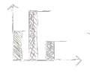
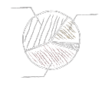

Keynote Speaker Details

Learn about the latest action research being carried out in mathematics classrooms. Research topics include:



Technology

Homework

Attitudes
Group work

Something

Something else!




Register at bit.ly/mathsed2021

